Conference Agenda
Wednesday, August 25, 2010

2:00 - 5:00 PM Registration / Exhibit Booth Setup* Conference Room ABC

3:00 - 5:00 PM Second Annual Grant Writers Workshop Conference Room F

The Upper Mississippi River Grant Writers Partnership (UMRGWP) will have its second annual conference workshop to review the work of the past year, add new members, and make plans for the year ahead. Everyone interested in learning about the partnership is welcome to attend. Conference registrants may attend the workshop free of charge; all others are $20. Drinks and snacks will be provided, and the workshop fee also covers the catfish dinner.
5:00 - 7:00 PM Welcoming Reception sponsored by Western Illinois University Conference Room ABC

7:00 PM Catfish Fry Moline riverfront behind the Radisson on John Deere Commons-Moline

*Exhibits will be displayed throughout the entire conference.

Thursday, August 26, 2010

7:30 - 8:30 AM Continental Breakfast Conference Room ABC

8:30 - 9:15 AM Opening Keynote Conference Room ABC

Welcome and Introductions, Conference Committee

Featured Presentation:

Innovations and Sustainability in City Planning
Pete Pointner, President
Corporate Services, Inc. (Wheaton, IL)

9:30 - 11:30 AM Concurrent Sessions Conference Rooms D, E, & F

Track 1 How are Farmers Addressing Agricultural Pollution? Conference Room D

Water Quality Challenges Facing the Upper Midwest
Dennis McKenna
Illinois Department of Agriculture (Springfield, IL)

Encouraging Farmers and Farmland Owners to Prepare and Implement Conservation Plans to Reduce Pollution
Sharon Hartzold, Resource Conservationist in Area 4
Natural Resources Conservation Service (Edwards, IL)

Addressing Policies
Paul Johnson
Paul served as the last director of the Soil Conservation Service and the first chief of the Natural Resources Conservation Service from 1994-97; he is working on a book about private lands conservation (Decorah, IA)

Track 2 Reinventing Waterfronts - Reviving the Water’s Edge Conference Room E

What it Takes to Become a Successful Waterfront Leader
Pat McGinnis
Horinko Group (Washington, DC)

What it Takes to Turn Things Around
Tom and Ann Meeker, Owners
The Pearl Button Paddlewheel Excursion boat and former owners of
The Button Factory Woodfire Grille (Muscatine, IA)

Make No Small Plans - The Clinton Marina & Candlelight Inn
Julie Allesee, President
Clinton Convention & Visitors Bureau (Clinton, IA)

Track 3 Why Should We Hire an Architect? Conference Room F

Adaptive Re-use With Imagination
John Gere, AIA, NCARB
Scholtz-Gowey-Gere-Marolf Architects & Interior Designers PC (Rock Island, IL)

New Designs for Transforming Landscapes
Scott Freres, RLA, Principal
The Lakota Group (Chicago, IL)

Letting the Land Dictate What is Done
Doug Adamson, Landscape Architect
RDG Planning and Design (Des Moines, IA)

11:45 AM - 1:00 PM Lunch Conference Room ABC

Featured Presentation:

Mississippi River Water Quality and the Clean Water Act:
Recent Reports from the National Research Council
Jeff Jacobs, Scholar
National Research Council (Washington, D.C.)

1:00 - 4:00 PM Charettes Conference Rooms D, E, & F

Keithsburg, IL - Conference Room D, Facilitator: Pete Pointner, FAICP, ALA, ITE (Corporate Services, Inc)
Devastated by the floods of 1993 and 2008, the City of Keithsburg is conscious of the importance of
sustainable riverfront development. Keithsburg is seeking design assistance for the development of a marina that will galvanize economic recovery and responsibly utilize the city’s greatest asset and
challenge – its proximity to the Mississippi River.

Buffalo, IA - Conference Room E, Facilitator: Scott Freres, RLA, Principal (The Lakota Group)
The City of Buffalo has an opportunity to develop a riverfront park that stretches three downtown city blocks. This project is in its earliest stages and the park is as of yet a blank canvas that is in need of ideas and solutions to guide its development.

Davenport, IA - Conference Room F, Facilitator: Ed Freer, Landscape Architect & Principal (JJR) The City of Davenport is midstream on a riverfront project to reclaim and redevelop the East Industrial Site. This project will significantly expand Davenport’s publicly accessible riverfront and the city wants to incorporate the best ideas and solutions available to give this area the makeover it deserves.
6:30 - 9:00 PM Celebration Belle Dinner Cruise Moline Landing, 2501 East River Drive

Friday August 27, 2010

7:30 - 8:30 AM Continental Breakfast Conference Room ABC

8:45 - 10:45 AM Concurrent Sessions Conference Rooms D, E, & F

Track 1 People Who Make a Difference - Taking What Matters into Their Own Hands Conference Room D

The Story of Living Lands and Waters*
LL&W Team Member
Living Lands and Waters (East Moline, IL)

Beautification in Revitalization - Greenway Habitat & Scott County Beautification
Dr. Michael Giudici
Greenway Habitat and Keep Scott County Beautiful (Davenport, IA)

All Aboard for Alternative Transportation QC Rail Initiative
Paul Rumler, Executive Vice President
Illinois Quad City Chamber (Moline, IL)

Track 2 Educators’ Panel - Are We Relevant to Everyone? Conference Room E

Is the Message Getting Through?
Rich Patterson, Director
Indian Creek Nature Center (Cedar Rapids, IA)

Learning to Play Wet
Dave Murcia, Director
Wapsi River Environmental Education Center (Dixon, IA)

Lessons Learned
Brian Ritter, Naturalist
Nahant Marsh Education Center (Davenport, IA)

Track 3 Leading Edge Projects - Inspiration for Future Development Conference Room F

Keokuk’s Lock & Dam 19 Interpretive Center
Mayor Tom Marion
City of Keokuk (Keokuk, IA)

Savanna Depot Project
Alan Anderson, Assistant Manager
US Fish & Wildlife Service, Lost Mound Unit (Savanna, IL)

11:30 AM - 1:30 PM Lunch Conference Room ABC

1:15 - 3:15 PM On the Water Field Trips
All trips depart from the docks behind TGI Fridays, Moline

Trip 1: What Did the Mississippi River Look Like 200 Years Ago? - Pool 16
Dr. Reuben Heine, Augustana College

Trip 2: River Landscape Mosaic - Pool 15
Dr. Norm Moline, Augustana College
Marshall Guth, RiverStone Group

Trip 3: Canoe or Kayak Sylvan Slough
Dave Murcia, Wapsi River Environmental Education Center

*The Living Lands and Waters tugboat will be in the Moline Pool adjacent to the iWireless Center. Conference attendees will have an opportunity to view the tugboat and ask questions of the LL&W Staff following the morning session.

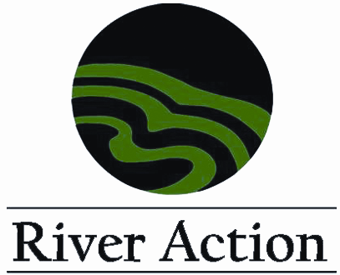




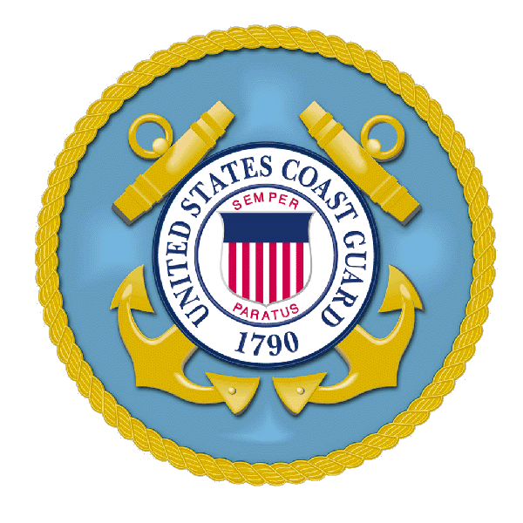
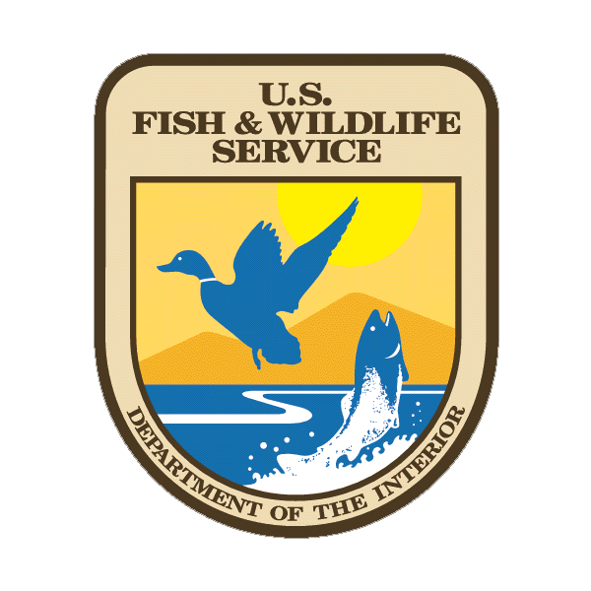
WAYS TO REGISTER:
Website registration: www.riveraction.org
Fax registration to (563) 322-0916 (Available 24 hours)
Mail registration form and payment to:
River Action, 822 E. River Drive, Davenport, IA 52803
Have Questions? Please contact:
River Action
Monday - Friday 7:30 am - 4:30 pm Central Time
Phone: 563-322-2969
Email: riveraction@riveraction.org
Attendees Last NameAttendees First Name

Attendees Last NameAttendees First Name

Attendees Last NameAttendees First Name

Occupation/Career FieldBusiness/Organization Name

AddressCityStateZip

TelephoneEmail
How did you learn about the Upper
Mississippi River Conference?
Website
Brochure
News Release
Colleague
Attended last year
Other _________________________

Registration Fee:
$25 Student Registration
$99 Early Registration (by 8/2)
$198 Group Discount - Pay for two registrations, receive third free
$149 Postmarked after 8/2
Cancellations: A partial refund will be honored before 8/2 (less $40 service charge).

Grantwriters Workshop:
$20 Fee to attend workshop only (included in conference registration)

Conference Exhibit Space:
$100 Booth Fee

Please assist us with meal counts by checking the box for all activities you plan to attend:
Wednesday, 8/25 Opening Reception
Wednesday, 8/25 Catfish Fry
Thursday, 8/26 Celebration Belle Dinner Cruise

Conference Field Trips:
Field Trip 1: What did the Mississippi River look like 200 years ago?
Field Trip 2: Channel Cat Water Trip
Field Trip 3: Canoe or Kayak Sylvan Slough

Continuing Education Credits Information:
Please indicate if you are seeking continuing education credits and need a certificate of attendance for the UMRC conference by checking this box

zz
Conference Sponsors:

Hotel Information:
Radisson On John Deere Commons-Moline
Located next to iWireless Center
1415 River Drive, Moline, IL 61265
Reservations: (888) 201-1718
Telephone: (309)764-1000 Fax: (309)764-1710

Stoney Creek Inn & Conference Center
Located one block from the i wireless Center
101 18th Street, Moline, IL 61265
Reservations: (800) 659-2220
Telephone: (309)743-0101

Visitor Information:
Quad Cities Convention and Visitors Bureau
www.visitquadcities.com

Conference Supporters:
Thank you to all our sponsors and supporters for your continued involvement
Payment Information:
Total Due: $_________________
Payment Method:
Check (Make payable to River Action)
Credit Card: Visa Mastercard
Name on Card ______________________________ Card Number ______________________________ Exp. Date ____/____ Signature _____________________________________________

Keynote Speakers:

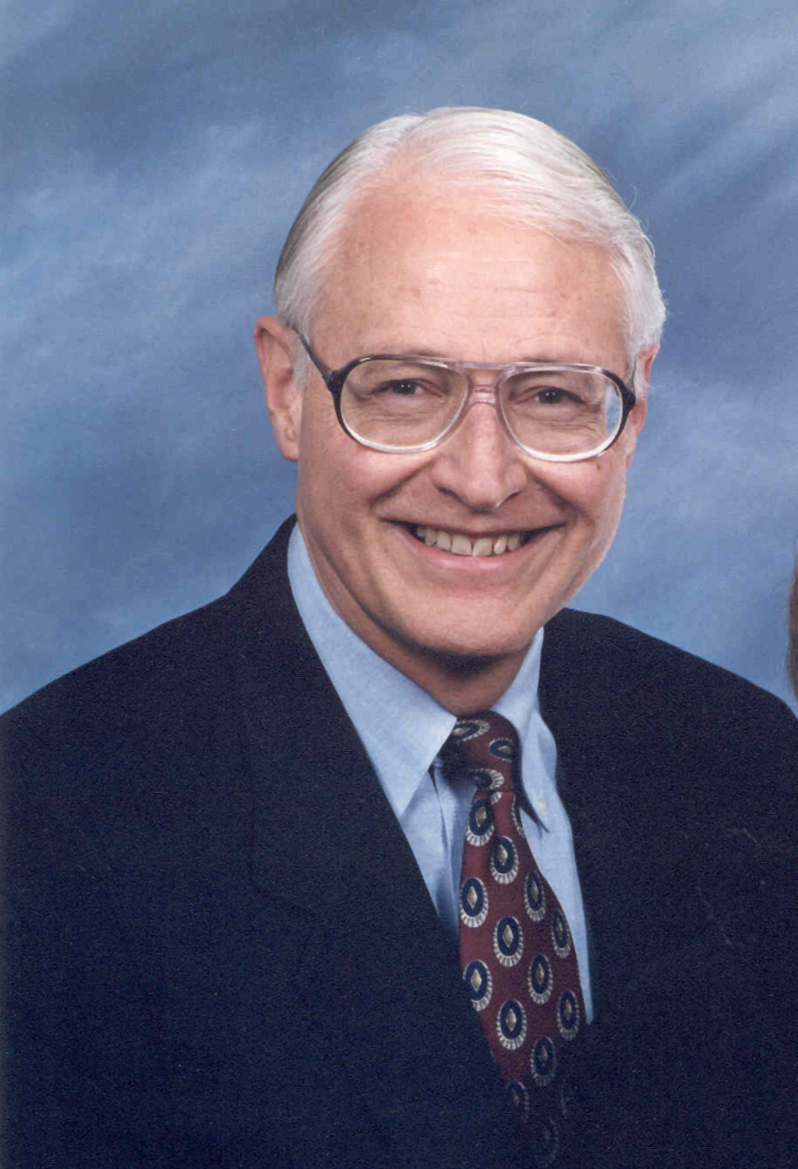
Pete Pointner, FAICP, ALA, ITE
Pete Pointner has focused his 49 year career on environmentally based planning and context sensitive design. He has taught at the university level and has extensive experience as a consultant, municipal planner and coordinating consultant for major public works projects and private developments that have won local, regional and national awards. He has directed projects in 25 states and 4 foreign countries and recently published a book, “Planning Connections: Human, Natural, and Man Made.” He currently is the president of Corporate Services, Inc. in Wheaton, Illinois.

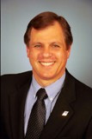
Jeff Jacobs, PhD
Jeff Jacobs is a resident scholar at the National Research Council in Washington. Jeff has been with the NRC for 13 years and has directed 25 studies on national water planning and management issues including Upper Mississippi River navigation and restoration; Louisiana coastal protection and restoration; and U.S. Army Corps of Engineers planning and analytical methods. Jeff has served as a faculty member at Texas A&M University and at the National University of Singapore. He holds a PhD degree in geography from the University of Colorado.

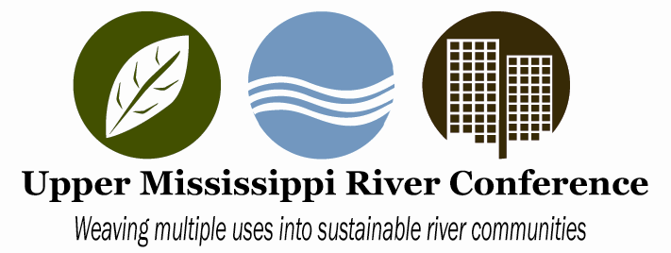

River Action, a non-profit organization that strives to foster the environmental, economic, and cultural vitality of the Mississippi and its riverfront in the Quad Cities region, with the support of the U.S. Army Corps of Engineers, U.S. Fish and Wildlife Service, and U.S. Coast Guard, sponsors the third annual Upper Mississippi River Conference, August 25-27, 2010, at the i wireless Center, Moline.

Targeting city planners, elected officials, landscape architects, architects, environmental groups, economic developers and environmental educators, the meeting will address best case studies in riverfront design programs, and projects, and provide attendees with resource to guide them through federal and state programs integral to implementing future projects. Additional assistance is being provided by Western Illinois University and Augustana College.

Planning Committee

Kathy Wine (Conference Chair)
River Action

Steve Ahrens
City of Davenport

Jeff Anderson
City of Moline

Marilyn Andress
Rock Island SWCD

William Boom
City of Davenport

Hank DeHaan
U.S. Army Corps of Engineers

Doug DeLille
Bi-State Regional Commision

Jon Duyvejonck
U.S. Fish & Wildlife Service

Mari Fournier
U.S. Army Corps of Engineers

Angela Freyermuth
U.S. Army Corps of Engineers

Jenny Garner
University of Illinois Extension

Mikael Holgersson
River Action

Lynn Hunt
Quad Cities Convention &
Visitors Bureau

Jerry Paulsen
Natural Land Institute

Lt. John Martin
U.S. Coast Guard
Dr. Norm Moline
Augustana College

Jerry Neff
Sierra Club

Scott Pettis
U.S. Coast Guard

Matt Schramm
Rock Island SWCD

Dr. Roger Viadero
Western Illinois University

